Requirements list
Company:
Project:
Machine power:
Figure 1 Simple representation of the system in a predefined coordinate set. The naming convention for machine ends are usually D-end (driven end), N-end (nondriven end). In case of two stages on different sides, the convention A-end, B-end is used where A is the first stage, B is the second stage, or A is the compressor and B is the turbine.

Operational speed range
Minimum and maximum operational speed of the machine and estimated nominal speed.
Description | Value
Nominal operational speed, rpm
Maximum operational speed, rpm
Lowest operational speed, rpm

Rotor mass
The rotor mass with all the known parts and components excluding process tools (impellers), those can be added in Section 10.
Description | Value
Rotor total mass (excluding magnetic bearing part), kg

Active part dimensions
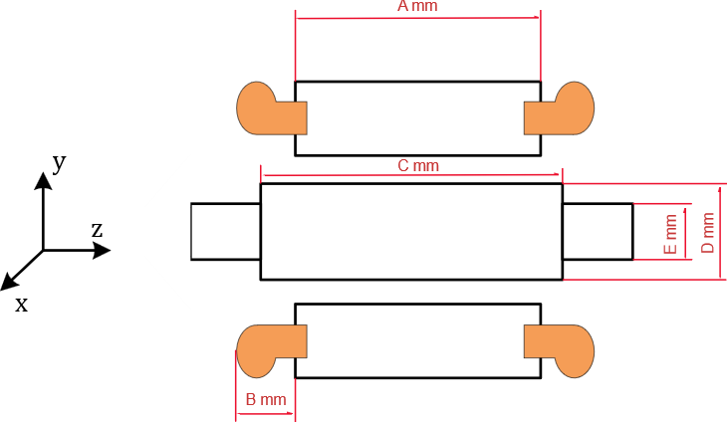
Figure 3 Main parameters of the active part
Description | Value
Active stator length (A), mm
End winding protrusion axial length (B), mm
Active rotor length (C), mm
Active rotor part diameter (D), mm
Shaft diameter (E), mm

Maximum allowed length of the machine with bearings
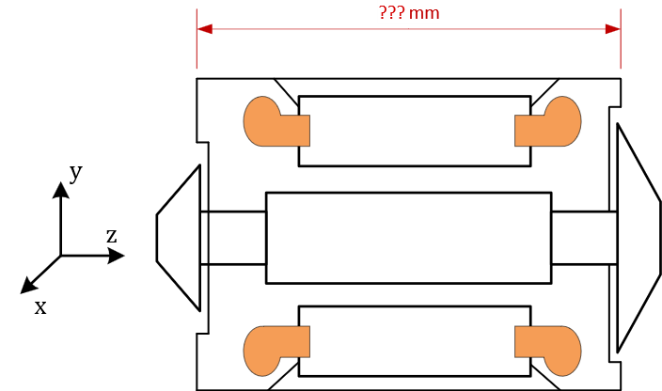
Figure 3 Length of the machine, excluding impeller housings and shrouds
Description | Value
Length, mm

System arrangement

Figure 5 Definition of gravitational force and corresponding system installation. Horizontal is on the left, vertical is on the right.
Define is system is installed in a vertical or horizontal arrangement, mark both if you expect that all might be necessary.
Arrangement | Value
Vertical
Horizontal

Clearances

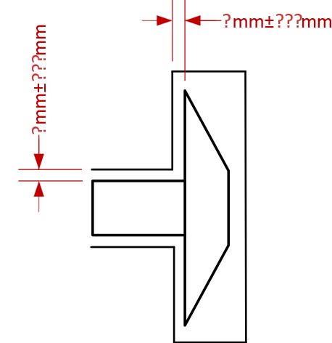
Figure 6 Example of clearances. For axial the clearance is between the impeller and backplate. For radial the clearance is between the shaft and housing. Please define the smallest ones for your system.
The necessary clearances between the stationary and the rotating tool and/or other important parts of the machine in axial and radial directions. Please specify the nominal value and tolerable deviations from that.
Description | Value | Allowable deviation
Axial clearance, mm |  | ±
Radial clearance, mm |  | ±

Residual unbalance of the rotor
Description | Value
Rotor balancing level, Gx.x

External forces acting on the rotor in radial direction
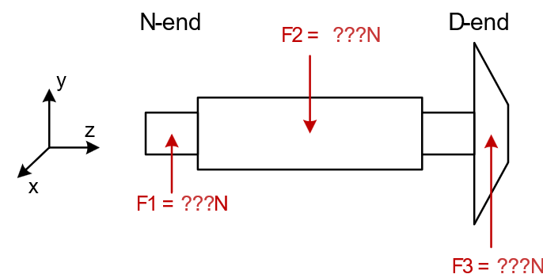
Figure 7 An example of forces acting on the rotor in a radial direction. When force is constant, the sign should be defined with respect to the coordinate system.
List all the external forces acting on the rotor or on the working tool attached to the rotor in a radial direction. List their magnitude, direction, frequency of the force and point of application. The maximum force values should be specified that occurs at any possible operating condition.
Description | Point of application | Frequency of the force | Value
Force, N

External forces acting on the rotor in axial direction
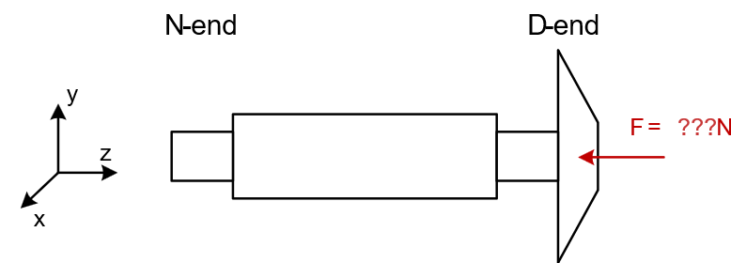
Figure 8 An example of force acting on the rotor in the axial direction. When force is constant, the sign should be defined with respect to the coordinate system.
List all the external forces acting on the rotor or on the working tool attached to the rotor in an axial direction. List their magnitude, direction and frequency of the force. The maximum force values should be specified that occurs at any possible operating condition.
Description | Frequency of the force | Value
Force, N

Working tools
Dimensions of the impellers or other working tools that will be used with the machine or range of there dimensions. In case there are several possible options and their arrangements, please group them, as they will be used by the same shaft.
Description | Mass, kg | Center of mass | Moments of inertia, kg m² | Overall dimensions

Operation conditions
Internal and external medium (air, vacuum, fluid, gas). Temperature and pressure for mediums.
Description | Notes
Surroundings
Process substance

Interfacing
Description of interfaces used to connect the machine to the process. This includes stator parts for the specific process cooling, for example, connections of the working tools to the shaft and so on.
Description | Notes

Speed sensor
What type of speed sensor if that is available.
Description | Notes

Extra technical notes
Notes

Business information
Business information related to the end-application is used for evaluating the economic benefits of applying SpinDrive technology.
Description | Notes
Application or process
Currently used technology in the application/process (if any) *
Annual operating hours
Estimated number of annually delivered units
Expected lifetime of the unit

*The application in which the machine will be used. For example, “screw compressor” in an air compressor application or “high-speed machine with air-foil bearings” in vacuum pump

In case value is not important, please leave it blank

